1. Open PowerPoint

2. On the "Design" tab, under "Slide Size," choose "Custom Slide Size..."
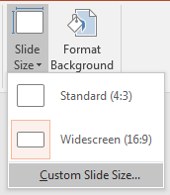

3. Under “Orientation,” “Slides,” choose either “Portrait” or “Landscape” (Most posters are done in Landscape)
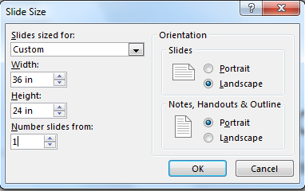

4. Set the "Width" and "Height" dimensions of the slide to either of these values:
Portrait Width 24 inches x Height 36 inches
Landscape Width 36 inches x Height 24 inches

5. Click on "OK"
continued →
6. Click on "Maximize"

7. After the PowerPoint slide (your poster) is finished, convert it to a PDF: save the PowerPoint file; then click on "File," "Save As," select a location to save the file, and choose "PDF" after "Save as type:"

8. Either bring the PDF to the IT Help Desk in the Library on a flash drive or submit an IT Help Desk ticket (helpdesk.sunyit.edu): after logging into the ticket system, choose "Create a new Service Request" → "Printing" → “Plotter Print Request” and be sure to attach the PDF poster

